**Fuzzy Logic controller with color vision system tracking for mobile manipulator robot**

Ahmad Taher Azar1, 2, Hossam Hassan Ammar2, Hazem Mliki2

1Faculty of Computers and Information, Benha University, Egypt

2Nile University, 6th of October City, Egypt

ahmad_t_azar@ieee.org; [hhassan@nu.edu.eg](mailto:HHassan@nu.edu.eg); hazem.mliki@eu4m.eu

**Abstract.** The purpose of this article is to present a theoretical and practical implementation of a fuzzy algorithm methodology to control a mobile manipulator path planning using a real-time vision system tracking. To meet high performance response and robust stability of the platform navigation, a fuzzy logic controller is designed with realistic constrains. OpenCV library is used to implement Background Modeling technique to track in real time a color object and to extract its (X, Z) coordinates, then an ultrasonic sensor is coupled with the camera to calculate the depth “Y” of the tracked object position. The inverse kinematics is used to control an arm robot to achieve a grasping task of the tracked object. The robot uses the vision system and the ultrasonic sensor to approximate the position of object compared to the cart as well as the position of the arm end effector to the target. The proposed technique shows through simulations and hardware implementhation the high efficiency of the algorithm implemented. The fuzzy controller technique presents a good stability and robustness behavior results. The obtained results conclude that the combination between a 2D vision system and an ultrasonic sensor applied to a rigorous fuzzy logic algorithm can perform good results similar to a tracking technique based on a 3D camera.

**Keywords:** Fuzzy logic controller, mobile manipulator robot, machine vision, Color tracking, Background Modeling, OpenCV, Inverse Kinematics.

1. Introduction

The field of mobile manipulator robot application is constantly changing and the greatest challenge tomorrow holds for us to manage this continuity of change [1]. Having prior knowledge on kinematics is very important especially when it comes to animation of articulated structures such as the robot arm [2]. Consequently, a critical step in any robotics system is the analysis and modeling of the kinematics system [3], which is divided into forward and inverse kinematics. The forward kinematics is mainly used to transfer joint variables values to compute the end effector position and the inverse kinematics determines the value of each joint in order to place the arm at a desired position and orientation. The focus of this system is to control a gripper to grasp and manipulate objects in its workspace. In this design, the algorithm is implemented in order to have a flexible framework for the motion planning and the control of the robot.

Mobile robot platforms have become an important part in different aspects of today’s modern applications in research and industry [4]. With the advances in controls theory, application of mobile robots in industry has shown growing interest towards automation [5]. The manipulator robot and the mobile cart are combined to navigate and accomplish grasping task in a wide range compering to the limited workspace of the arm robot. To reach the goal, a fuzzy logic algorithm that consider the maximum of constrains in real scenarios is designed and implemented. The design of the controller follows the method of fuzzification, engine inference and defuzzification technic. Rules are refined to meet with realistic scenarios for the mobile manipulator navigation.

A vision system is added to locate the target object inside the space in which the robot can operate. A simple 2D vision system is coupled with an ultrasonic sensor to compute in real time the actual goal objet. First the 2D camera extract the (X,Y) coordinates using background modeling technique, the robot will navigate to the indicated position and then it joins the (X,Z,Y) to approach the final location using the depth extracted from the ultrasonic sensor.

The design challenges of a control system in this regard are the response overshoot, shorter settling time and smaller steady state error.

This article presents a fuzzy controller algorithm. The method discussed in this article try to generate best outputs performances. The controller proposed results with a fast time response and high stability. The obtained results are very promising. The rest of the paper is organized as follows: The mathematical model is presented in Section 2. While in Section 3, the controller design of the fuzzy logic algorithm is introduced and explained. In section 4, all results are shown under different tests and inputs. In addition, the discussion section and a conclusion is written to conclude this article.

1. Mathematical model
   1. Kinematic model of a nonholonomic mobile robot

The main feature of the kinematic model of wheeled mobile robots is the presence of nonholonomic constraints due to the rolling without slipping condition between the wheels and the ground [6].

The system-generalized velocities cannot assume independent values; in particular [7], they must satisfy the constraint entailing that the linear velocity of the wheel center lies in the body plane of the wheel, which is the zero lateral velocity [8]:

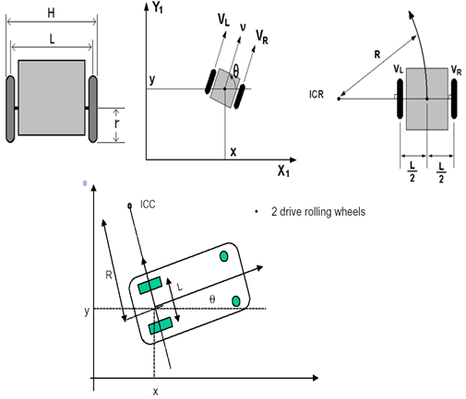

**Fig. 1.** **Kinematic model of a nonholonomic mobile robot**

P= , ()

, y+ ()

**and** ()

The relation between the control input and the speed of wheels these equations is determined:

**and**  ()

**and** ()

()

The system is subject to two nonholonomic constraints, one for each wheel.

()

()

**Table 1.** PHYSICAL PARAMETERS OF NONHLONOMIC ROBOT

|  |  |
| --- | --- |
|  | Cartesian coordinate of the front wheel |
|  | Cartesian coordinate of the front wheel |
|  | Linear velocity |
|  | Orientation of the robot |
|  | Angular velocity |
|  | the distance between the wheels |
| *r* | Radius of each wheel |
|  | Instantaneous curvature radius of the robot trajectory |
| ICC | Instantaneous center of curvature |
|  | he linear velocity of the right wheel and left wheel respectively |

()

()

* 1. Mathematical modeling of a DC motor.

A common actuator in control systems is the DC motor [9]. It directly provides rotary motion and, coupled with wheels or drums and cables, can provide translational motion. The electric equivalent circuit of the armature and the free-body diagram of the rotor are shown in the following figure [10].

The torque generated by a DC motor is proportional to the armature current [11] and the strength of the magnetic field. In this case, the magnetic field is assumed to be constant [12] and, therefore, that the motor torque is proportional to only the armature current i by a constant factor [13]as shown in the equation below.

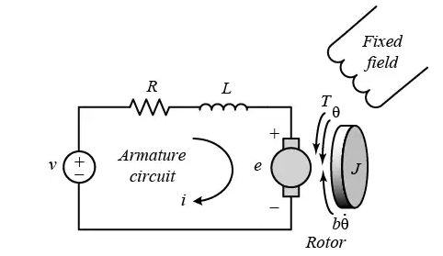

**Fig. 2.** Model representation of a DC motor

**Table 2.** PHYSICAL PARAMETERS OF DC motor

|  |  |
| --- | --- |
| J | Moment of inertia of the rotor (kg.m^2) |
| b | Motor viscous friction constant (N.m.s) |
|  | Electromotive force constant (V/rad/sec) |
|  | Motor torque constant (N.m/Amp) |
| R | Electric resistance (Ohm) |
| L | Electric inductance (H) |
|  | angular velocity of the shaft |

()

()

In SI units, Kt = Ke ; therefore, K is used to represent both the motor torque constant and the electromotive force.

()

()

From eq (13) and (14), the Laplace transform is applied and the results are shown by the modeling equations:

()

()

()

1. Controller design

The design target of the system is to control the cart robot with a fuzzy logic algorithm in same time with the arm robot [14]. Therefore, the design task is divided into two parts. The design process is started by the cart robot controller to perform good navigation results.

A typical structure of a fuzzy logic controller is shown in Fig. 8. Using a preprocessor, the inputs that were in the form of crisp values generated from feedback error (e) and change of error (de) [15] were conditioned in terms of multiplying by constant gains before entering into the main control block. The fuzzification block converts input data to degrees of membership functions and matches data with conditions of rules. From the rule based commands, the Mamdani-type inference engine determined the capability of degree of employed rules and returned a fuzzy set for defuzzification block where the fuzzy output data were taken and crisp values were returned.

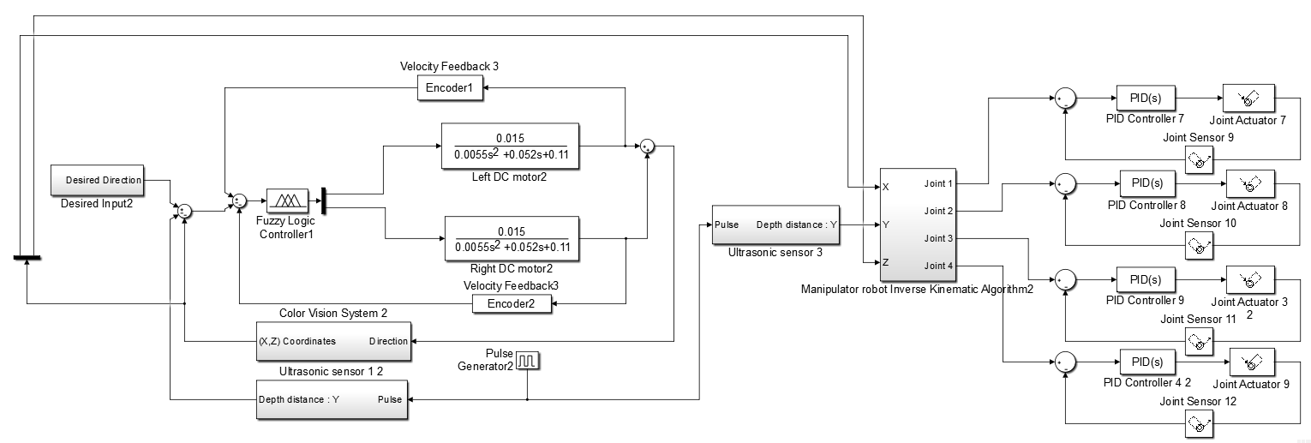

**Fig. 3.** Block diagram of mobile manipulator robot based Fuzzy logic controller

The outputs of the fuzzy sets were converted to crisp values through centroid fuzzification method [16]. The post-processing block then converted these crisp values into standard control signals [17]. In this project, experiential knowledge was borrowed from proportional integral control error and change of error to define fuzzy membership functions. The rule Table 1 was then designed and used with a triangular membership function inputs-output in the fuzzy logic controller and was implemented in the simulation.

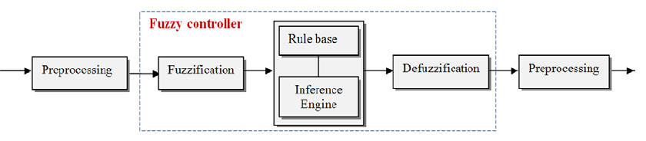

**Fig. 4.** Fuzzy logic controller block diagram



**Fig. 5.** Example of Fuzzy logic output variable, control

These rules make control efforts based on several if-then statements about (e) and (de), i.e., if the error is equal Negative Big (NB) and change of error is equal to negative medium (NM), then the change in control (c) is positive big (PB) [18]. The numbers of these if-then statements were determined based on experiment and tuning of the system. Plots of fuzzy logic membership function *f* the output (c) is shown in Fig. 6.

**Table 3.** Fuzzy logic controller rules table

|  |  |  |  |  |  |  |  |  |  |
| --- | --- | --- | --- | --- | --- | --- | --- | --- | --- |
| De/e | NVB | NB | NM | NS | Z | PS | PM | PB | PVB |
| NVB | PVB | PVB | PVB | PB | PM | PM | PS | Z | Z |
| NB | PVB | PVB | PB | PM | PS | PS | PS | Z | Z |
| NM | PVB | PB | PM | PS | PS | Z | Z | Z | NS |
| NS | PB | PM | PM | PS | PS | Z | Z | NS | NS |
| Z | PM | PM | PS | Z | Z | Z | NS | NS | NM |
| PS | PM | PS | PS | Z | NS | NS | NM | NM | NB |
| PM | PS | PS | Z | NS | NS | NM | NB | NB | NB |
| PB | PS | Z | Z | NS | NM | NM | NB | NVB | NVB |
| PVB | Z | Z | NS | NM | NM | NB | NB | NVB | NVB |

1. Results and discussion
   1. Cart robot controller’s results

The performances of the fuzzy logic controller are simulated in MATLAB© and also implemented in real mobile manipulator robot. A signal generator produces input references for each control blocks. The fuzzy logic controller block processes the inputs, output of fuzzy inference engine, and generate control signal to control the DC motor dynamic model. The behavior of the closed loop response and the performance of the controllers were evaluated by input step functions with results plotted in Fig 6 and 7.

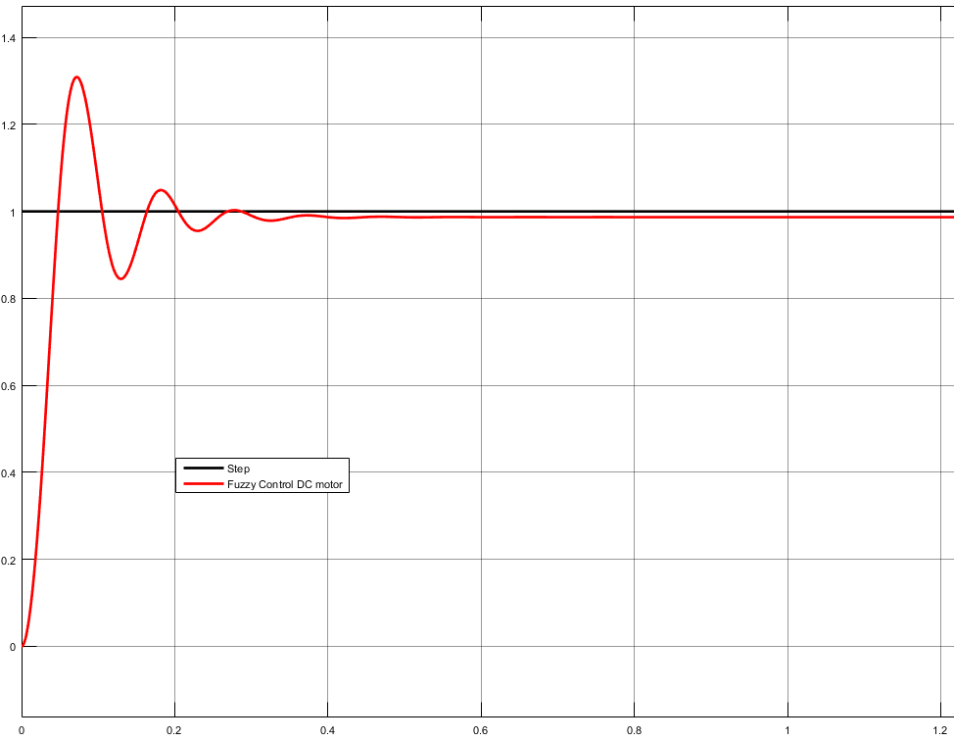

**Fig. 6.** Step response of the Fuzzy logic controller

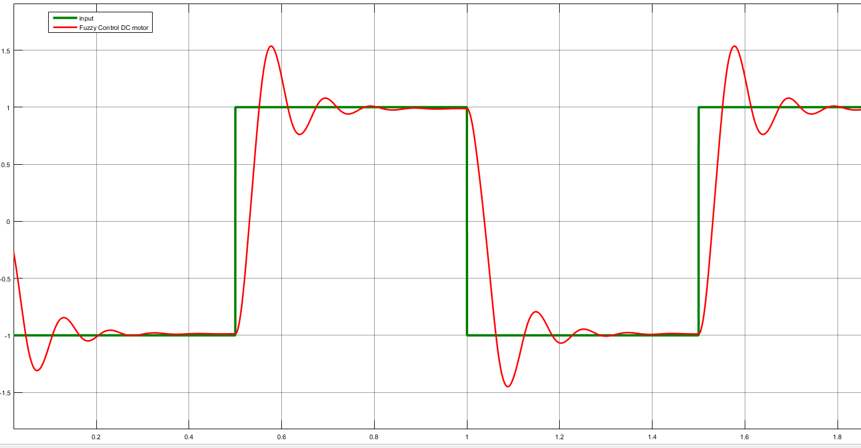

**Fig. 7.** Fast change input response of the Fuzzy controller

The above simulations show that the fuzzy controller can satisfactorily control a variety of processes. It yields a good control performance, which is confirmed by comparing performances indexes such as the percent maximum overshoot, settling time, and the stability**.**  The Fuzzy logic controller is quietly faster however, it has a problem of maximum overshoot, which exceeds 27%. In addition, it has a permanent steady state error as shown in fig.6.

1. Conclusion

The mobile manipulator platform requires precise autonomous devices to perform labor-intensive task such as data collections and image acquisition. This study discussed about simulation and analysis of the fuzzy design for speed control of a DC motor actuator that was used in a mobile robot platform, which moves between crop rows to collect image data and to track an object due to its color. A linear differential equation describing the electromechanical properties of a DC motor to model the relation between voltage input and shaft rotation output was first developed using basic laws of physic. This transfer function was then used to analyze the performance of the system and to design proper controllers to meet the design criteria. To achieve smoother control, a fuzzy logic controller with two inputs and one output including was designed. The results showed that for rectangular changes of the robot speed, the fuzzy logic controller has a good performance in terms of rise time.

References

1. Albu-Schäffer A., Haddadin S., Ott C., Stemmer A., Wimböck T., Hirzinger G. (2007). The DLR lightweight robot: Design and control concepts for robots in human environments”, Industrial Robot, vol. 34, no. 5, pp. 376–385, 2007.
2. Bøgh S., Hvilshøj M., Myrhøj C., Stepping J. (2008). Future Manufacturing Assistant – The Mobile Robot “Little Helper”, Master Thesis, Aalborg University.
3. EUROP (2009). Robotics visions to 2020 and beyond, The Strategic Research Agenda for Robotics in Europe.
4. Hamner B., Koterba S., Shi J., Simmons R., Singh S. (2009). An autonomous mobile manipulator for assembly tasks, Autonomous Robot, vol. 28, pp. 131–149.
5. Hentout A., Bouzouia B., Akli I., Toumi R. (2010). Mobile Manipulation: A Case Study, Robot Manipulators, New Achievements, ISBN 978-953-307-090-2.
6. Ma, Y., Liu, Y., and Wang, C. (2010) "Design of Parameters Self-Tuning Fuzzy PID Control for DC Motor," Second International Conference on Industrial Mechatronics and Automation (ICIMA), 30-31 May 2010, vol. 2, pp. 345-348.
7. Naik, K.A. and Shrikant, P. (2011) "Stability Enhancement of DC Motor using IMC Tuned PID Controller," International Journal of Advanced Engineering Sciences and Technologies, vol. 4, No. 1, pp. 092-096.
8. Haung, G. and Lee, S. (2008) "PC Based PID speed control of DC motor," In: 2008 International Conference on Audio, Language and Image Processing, Shanghai, 2008, pp. 400-407. doi: 10.1109/ICALIP.2008.4590052
9. Anatolii, S., Naung, Y., Oo, H. L., Khaing Z. M., and Ye, K. Z. (2017) "The comparative analysis of modelling of simscape physical plant system design and armature-controlled system design of DC motor," 2017 IEEE Conference of Russian Young Researchers in Electrical and Electronic Engineering (EIConRus), St. Petersburg, 2017, pp. 998-1002. doi: 10.1109/EIConRus.2017.7910725.
10. Bolívar-Vincenty, C.G., Beauchamp-Báez, G. (2014) “Modelling the Ball-and-Beam System From Newtonian Mechanics and from Lagrange Methods” Twelfth LACCEI Latin American and Caribbean Conference for Engineering and Technology; July 22 - 24, 2014
11. Meenakshipriya, B., Kalpana, K. (2014) Modelling and Control of Ball and Beam System using Coefficient Diagram Method (CDM) based PID controller, In IFAC Proceedings Volumes, Volume 47, Issue 1, pp. 620-626.
12. Tudoroiu, R.E., Ilias, N., Kecs, W., Casavela, S. V., Dobritoiu M., and Tudoroiu, N. (2016) "Real-time implementation of DC servomotor actuator with unknown uncertainty using a sliding mode observer," 2016 Federated Conference on Computer Science and Information Systems (FedCSIS), Gdansk, pp. 841-848.
13. Abdallaa, T.Y., Abed, A.A., and Ahmed, A.A. (2017) “Mobile robot navigation using PSO-optimized fuzzy artificial potential field with fuzzy control”, Journal of Intelligent & Fuzzy Systems, vol. 32, no. 6, pp. 3893-3908.
14. Gupta, M., Behera, L., and Venkatesh, K. S. (2010) "PSO based modeling of Takagi-Sugeno fuzzy motion controller for dynamic object tracking with mobile platform," Proceedings of the International Multiconference on Computer Science and Information Technology, Wisla, 2010, pp. 37-43. doi: 10.1109/IMCSIT.2010.5680034.
15. Nasrinahar, A., and Chuah, J. H. (2016) "Effective route planning of a mobile robot for static and dynamic obstacles with Fuzzy Logic," 2016 6th IEEE International Conference on Control System, Computing and Engineering (ICCSCE), Batu Ferringhi, pp. 34-38. doi: 10.1109/ICCSCE.2016.7893541
16. Parrilla, E., Riera, J., Torregrosa, J.R., (2010) Fuzzy control for obstacle detection in object tracking. Mathematical and Computer Modelling, Vol. 52, No., 7–8, pp. 1228-1236.
17. Masmoudi, M.S., Krichen, N., Masmoudi, M., Derbel, N. (2016) Fuzzy logic controllers design for omnidirectional mobile robot navigation, Applied Soft Computing, Vol. 49, No. 2016, pp. 901-919.